# Stepper motor driver

2209 and 2208 have the same pinout, this should mean that they are interchangeable when it comes to the footprint on the pcb.

For layout considerations **check chapter 19** of the tmc2208 datasheet.

### Later findings

The TMC2209 is the definitive replacement of the TMC2208 and TMC2130, so there is no good reason to keep using the depreciated TMC2208 in further designs.

## Micro stepping

Normally a stepper motor has 200 steps per complete revolution. Micro stepping can give you up to 51200 steps per complete revolution (depents on the motor of course) or 1/256 steps.

Benefits: improves noise levels and motor smoothness/accuracy and could improve energy effiency.

Drawbacks: decreases torque (especially at higher speeds) which could lead to stalling (some drivers can change stepping modes accordingly to speed).

source on Micro stepping <https://www.youtube.com/watch?v=G8oGa2mawKk&t=68s>

# UART on the TMC2209

Using the UART function of the TMC2209 we gain control many new functions including:

* Access to the control register
* Programmable 256 uStep sequencer
* Pulse generator
* SpreadCycle
* StealthChop
* Access to OTP

It is be possible to remove the STEP and DIR connections if we use UART to control one motor.

## UART Problem with multiple drivers

When connection multiple drivers you are able to read/write commands to the drivers individually using the same bidirectional line:

Strangely enough I not figure out why the above configuration did not work.

I configured one driver to be 01 and the other 00 by connection the ms1 and ms2 to GND and VCC the way it was shown in figure 4.1 above.

These are the configurations I tested:

|  |  |  |  |  |
| --- | --- | --- | --- | --- |
|  | PDN UART | TMC software address settings | Result | Additional notes |
| TMC driver A | Connected to RX | 1 | Functional | Changing one address to 0 also makes it NOT functional |
| TMC driver B | Floating | 1 |  |  |
|  |  |  |  |  |
| TMC driver A | Floating | 0 | Functional |  |
| TMC driver B | Connected to RX | 0 |  |  |
|  |  |  |  |  |
| TMC driver A | Connected to RX | 0 | NOT Functional |  |
| TMC driver B | Floating | 1 |  |  |
|  |  |  |  |  |
| TMC driver A | Floating | 0 | NOT Functional |  |
| TMC driver B | Connected to RX | 1 |  |  |
|  |  |  |  |  |

Conclusion: The driver UART control only works if there is one driver connected to RX and assigned address to this driver is selected in software (according to the ms1 + ms2 settings you chose). You can however use 2 drivers if you go with the “more than 4 drivers solution” which Trinamic provided. This could be achieved with transistors I suppose.

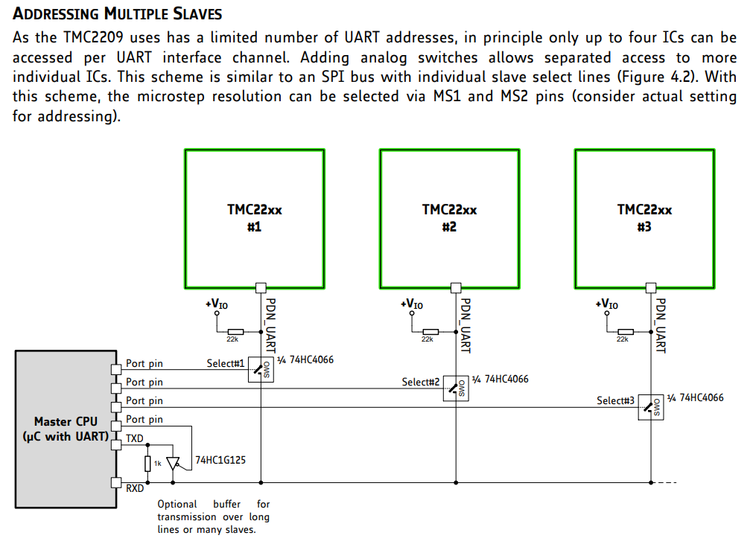

If reading from the driver is not required, using the write only function as seen in figure 4.1 of the datasheet is a viable option. This way we only need to use n+1 pins of the raspberry pi to control the motors, where n increases with every driver added (enable pin). This would treat all steppers as the same and would control them using the enable pin and sending data over the RX pin.

Configuration (test script 05: vactual.py) **RX and TX are flipped** **on the picture:**

This is what a successful transmission, with a few rotations and direction changes should look like.

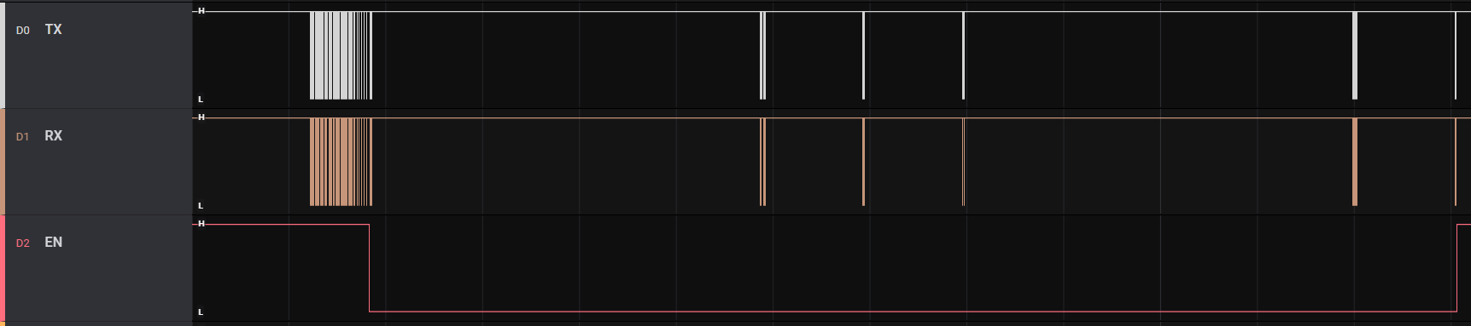

When zoomed in it is clear that the TX deviates from the RX line data.

Further inspection shows that it does sometimes match the RX line

It is however always the case that TX continues sending after RX is done with a package.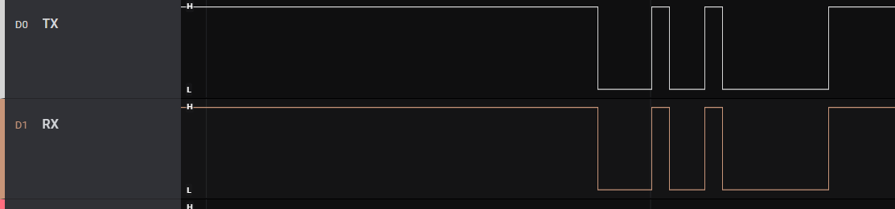

It is however always the case that TX continues sending after RX is done with a package.

Using these settings (test script 06: multiple drivers.py) **RX and TX are flipped** **on the picture:**

This is what a unsuccessful transmission looks like: 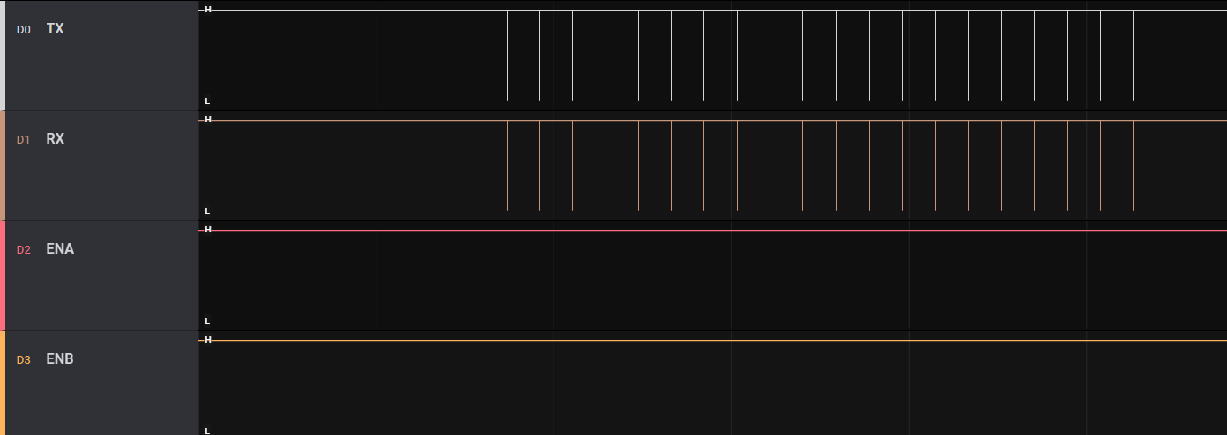

When zoomed in it seems that TX receives exactly the same information as it sends out. While, as stated earlier, it is expected that TX sends more data after RX is finished.

### Conclusion multiple drivers UART error:

I can conclude that somehow TX is getting the same information as it sends out on the RX line.

Fix found by Thomas Ijsseldijk: lowering the TX resistor to 500ohms increases the voltage available for the IO of the TMC driver which results in the TMC being able to read the signal. It appears to be very important to choose the right resistor value. It is now possible to control the stepper motors via UART. This reduces the pins required on the raspberry pi with 7 pins (removing all step and dir and the enable pins).